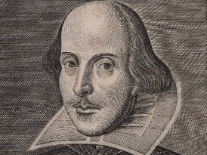

Age: 13-18

Aim: Familiarise

Students with Shakespeare’s

writing

**Activity sheet for peer teaching**

Description of Activity:

First of all , the students are introduced to Shakespeare by reading an exert of Romeo and Juliet aloud. After that, they will be introduced to two scenes depicting the same passage of Shakepeare’s Romeo and Juliet differently. The students will get a chance to discuss this with their respective partners. After that they can use the provided information to write a short dialogue in Elizabethan English, which they will share with their partner. _______________________________________________________________________________________________________________________________________________________________________________________________________________________________________________________________________________________________________________________________________________________________________________________________________________________________________________________________________________________________________________________________________________________________________________________________________________________________________________________________________________________________________________________________________________________________________________________________________________________________________________________________________________________________________________

Funded through

Key Questions:

* How did Shakespeare write
* What knowledge do I need to understand Shakespeare

Resources: Printer (Worksheets), Projector or Smart Board

Previous knowledge needed:

7th grade English

Cross curricular links: History, English