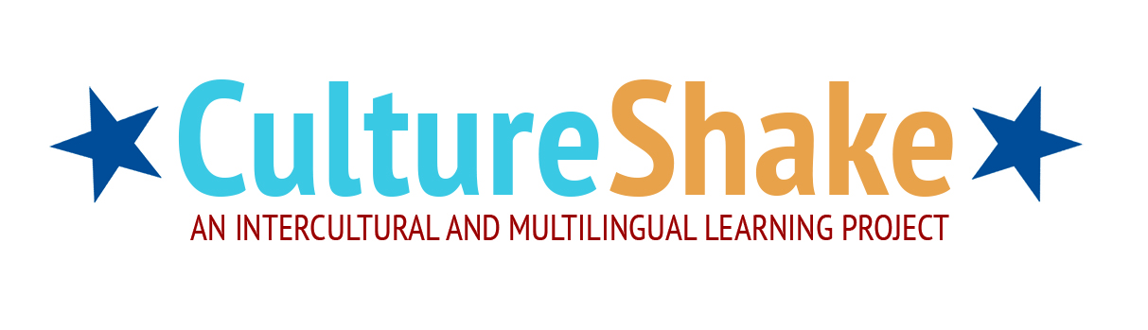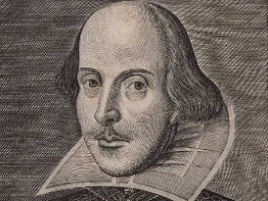

**Activity sheet for peer teaching**

Description of Activity:

________________________________________________________________________________________________________________________________________________________________________________________________________________________________________________________________________________________________________________________________________________________________________________________________________________________________________________________________________________________________________________________________________________________________________________________________________________________________________________________________________________________________________________________________________________________________________________________________________________________________________________________________________________________________________________

Funded through

Age:

Aim:

Key Questions:

Resources:

Previous knowledge needed:

Cross curricular links: