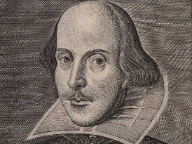

Aim:

Understand the play Hamlet and

Key Questions:

-What do you know about Shakespeare?

-What is the setting, situation and the characters of your scene?

-what do you know about the quote? (Hamlet)

**Activity sheet for peer teaching**

Description of Activity:

-Give the students the quote “To be or not to be: That is the question”   
-Asked them if they know the quote and where it comes from   
-Give examples how to use the quote in a small sketch (should always be at the end)  
-Give the students the task to invent a scene on their own

-Help the students during the process by giving them hints  
-Every group presents their result in front of the class  
-Discuss about the results  
-Read a short summary about Hamlet and talk about the quote and its context

-Compare it to the students results

___________________________________________________________________________________________________________________________________________________________________________________________________________________________________________________________________________________________________________________________________________________________________________________________________________________________________________________________________________________________________________________________________________________________________________________________________________________________________________________________________________________________________________________________________

Funded through

Age: 8-10

Resources:

-What you need for the small scenes

Previous knowledge needed:

-Basic knowledge about acting  
-small background on Shakespeare

Cross curricular links:

Acting

History

English