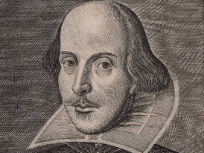

Description of Activity:

Short introduction to *The Tempest*:

Start the lesson with a short video that gives a modern English summary of *The Tempest*. Make sure that the students remember at least the main characters. Go on with giving them some lines from *The Tempest* and ask them to put them in the right order. If they struggle, help them with giving clues from within the text.

_________________________________________________________________________________________________________________________________________________________________________________________________________________________________________________________________________________________________________________________________________________________________________________________________________________________________________________________________________________________________________________________________________________________________________________________________________________________________________________________________________________________________________________________________________________________________________________________________________________________________________________________________________________________________________

Aim:

Get to know the Tempest

Resources:

<https://www.youtube.com/watch?v=kgjtCQlAdnI> RSC Video Tempest,

Sheet with lines (on CUSHA website, file called The Tempest re-ordering lines)

Age: 14-18

**Activity sheet for peer teaching**

Funded through

Key Questions:

* What is the Tempest about?

Previous knowledge needed:

English

Cross curricular links:

Literature

English